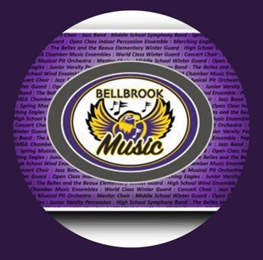
Bellbrook Music Boosters
10Jan2022
6:15 pm
Zoom Meeting ID #: 849 9858 1122
Meeting Recorded in its Entirety
Executive Board Meeting Minutes

Call to Order: 6:17 pm
Roll Call: Melanie Glover, Kevin Hobbs, Heather Newell, Rod Silva, Rachele Alban, Jon Selvaraj, Karen Beidelschies, Danielle Woeste, Phoebe Dickman, Andy Soloman, Barb Siler, Jen Volmer, Vice Principal Todd Whalen
- Absent: Larissa Scott
Welcome:
Approval of the Executive Meeting Minutes, 05Dec2021:
- Phoebe Dickman, 1st motion, Jon Selvaraj, 2nd, All Approved

Old Business:
- Poinsettia Sale
  - Chair of the sale, Heather Newell, reported on this year’s profits.
    - 2021 Booster Profit: $3177.70 (30% increase in sales from 2020)
    - 2021 Student Credit Distribution: $761.80.
  - Heather thanked all of the students/families for the great sales, as well as all of the volunteers who assisted at pick up.

- Winterguard Budget Update
  - Treasurer Kevin Hobbs reported that the Boosters have received approximately $1,950 of the money we are owed (out of $9,000+) from the 2021 Winterguard season, after Director Barb Siler had contacted Tamara Cary.
  - Kevin, President Melanie Glover, and Trustee Chair Larissa Scott will continue to have an offline conversation with Guard Director Sheldon Apo in attempt to resolve this issue.

- Winter Invitational Update
  - Invitational Chair Danielle Woeste reported that the next planning meeting will be on 11Jan2022 at 6:30 pm via Zoom.
  - There are currently 39 groups registered for the event that will be held on 05Feb2022.
  - Further details shared by Director Andy Soloman:
    - MEPA will be requiring that everyone in the building be masked with the exception of performers: in the warm up area and when they are actually performing. MEPA to “police” their mask policy.
    - MEPA is leaving capacity limits, concessions, and volunteer guidelines up to our Boosters/District.
    - Per Danielle, we will contact as planned for a “normal year” (pre-Covid) unless MEPA or the District make changes, impose new rulings.

- Concert Attire, status of requesting funds
  - Barb Siler will contact the Bellbrook Optimist Club regarding a donation towards the purchase of new concert band attire.
  - The plan is to approach the Bellbrook Lion’s Club for donations for new marching band uniforms in the near future.
New Business

- Treasurer’s Report-Appendix A
  - Financial Audit due
    - The yearly financial audit is due in January per the BMB By-Laws. However, due to the advisement of the Audit Committee, the audit will be postponed due to safety concerns about meeting in person, in relation to the current Covid-19 surge.
    - The audit will be rescheduled at a later date when deemed safe to do so.

- Board of Trustees’ Report
  - Trustee Chair Larissa Scott not present. However, all of the Trustees will be having a meeting on 17Jan2022 to discuss topics such as parent involvement and communication.
  - Their meeting that was scheduled on 09Dec2021 with Directors Soloman and Siler to discuss what the expectations of the Directors are and how the Boosters can meet them has been postponed and not yet rescheduled.

- Officer’s Report
  - The four Officers in attendance have nothing to report at this time.

- Director’s Report-Appendix B
  - Update on Grand Nationals meeting held in Dec2021 between Mr. Soloman, Dr. Cozad, and Mr. Hann
    - Mr. Soloman reports that the District has stated that they will cover the full cost of bussing for Grand Nationals 2022.

  - Update on Bob Roger’s transportation quote
    - Mr. Soloman also reports that the quote for bussing was $8,400.

- 8th Grade Night:
  - This event will be held in the BHS Band Room on 06Feb2022 at 6pm. The purpose of the event is primarily to discuss HS Music Program Curriculum choices for the incoming Freshmen class.
  - The Boosters, various fundraising events, and Band Trips (Disney World and NYC) will also be discussed.
  - We will decide if we will have refreshments as the date draws nearer due to the current Covid-19 climate.

- District Chamber Music Showcase
  - This event will be held on 22Jan2022 in the BHS Auditorium.
  - President Melanie Glover stated that the Boosters will generate a presence at the event, but we will need to determine what our comfort level is, in regards to the Covid-19 climate, as the event draws nearer.

- Bellbrook Concert Band Festival
  - This event will be held on 24Feb2022 in the BHS Auditorium.
  - Like in 2020, the plan will be for the Boosters to provide a concession stand if it is appropriate in concern to the Covid-19 climate at that time.

- Future Planning for Marching Band Season 2022:
  - Homecoming will be held on 24Sept2022, which is earlier than usual.

- Administrator’s Report
  - Vice Principal Todd Whalen has nothing to report at this time. The Administration continues to offer their full organizational and logistical support to all of Bellbrook’s Music Programs.

- Fundraising
  - Report held for the General Membership Meeting.

Adjourn: 7:07 pm
- Kevin Hobbs ,1st motion, Rachele Alban, 2nd

APPENDIX A
Treasurer Report
10Jan2022
Page 1/6

Balances
Checking $50,057.14 (Includes 12K of NYC Deposits)
Savings $64,522.93

Booster Funds Overview:
Fiscal YTD Revenue: $ 40,843.83
Fiscal YTD Expenses: 36,080.69
Fiscal YTD Surplus/(Deficit): $ 4,763.14

Monies Received from Donations/Fundraisers
# | Source | Amount
1 | Scrip Distribution | $ 1,504.32
2
3
4
5

Treasurer Activities/Notes/To-Do’s
# | Status | Description
1 | ■ | 2021 990-EZ Tax Filing Drafted – Awaiting Online Service
2 | ✓ | Completed 1099-NEC Filing
3 | ■ | Reimbursement for 2020-2021 Winter Guard expenses (Sheldon)
4 | ■ | Document Future Needs (Uniforms, Replacement of worn-out assets)
5 | ■ | Draft of Treasurer’s Playbook
6 | ■ | Combined Federal Campaign: Application Process

Graphs: SEE BELOW

APPENDIX A
Treasurer Report
10Jan2022
Page 2/6

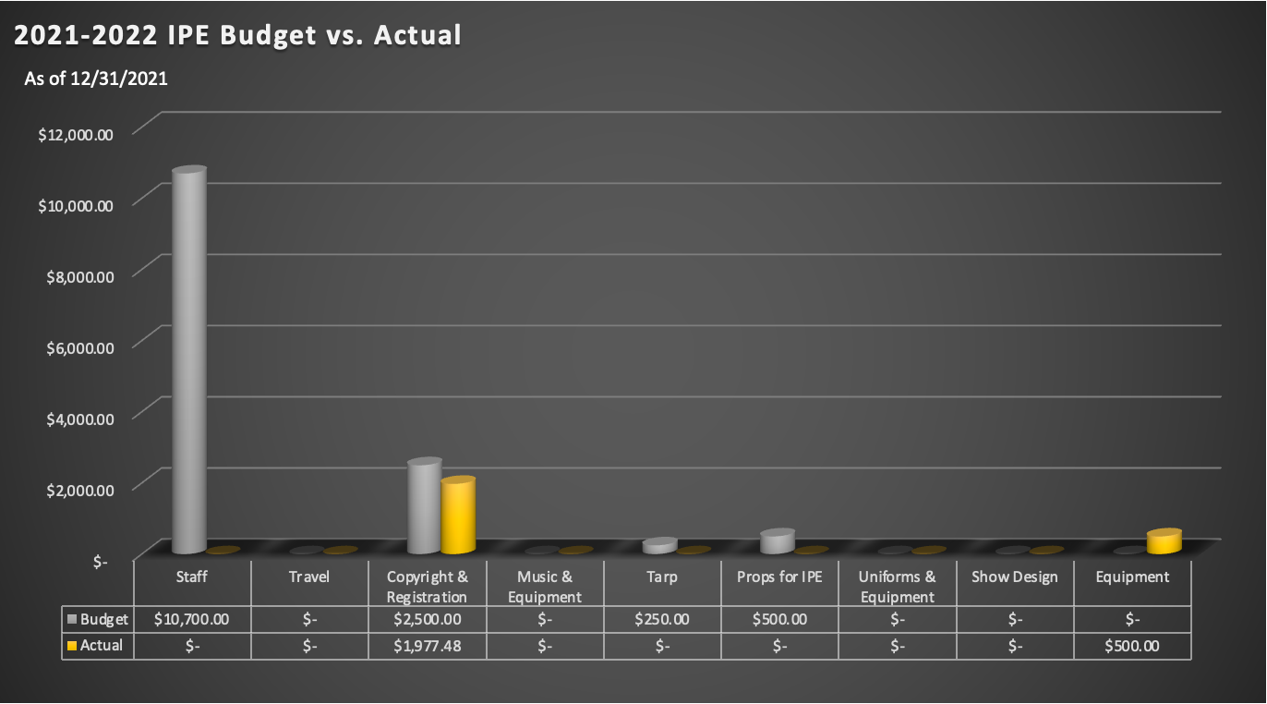
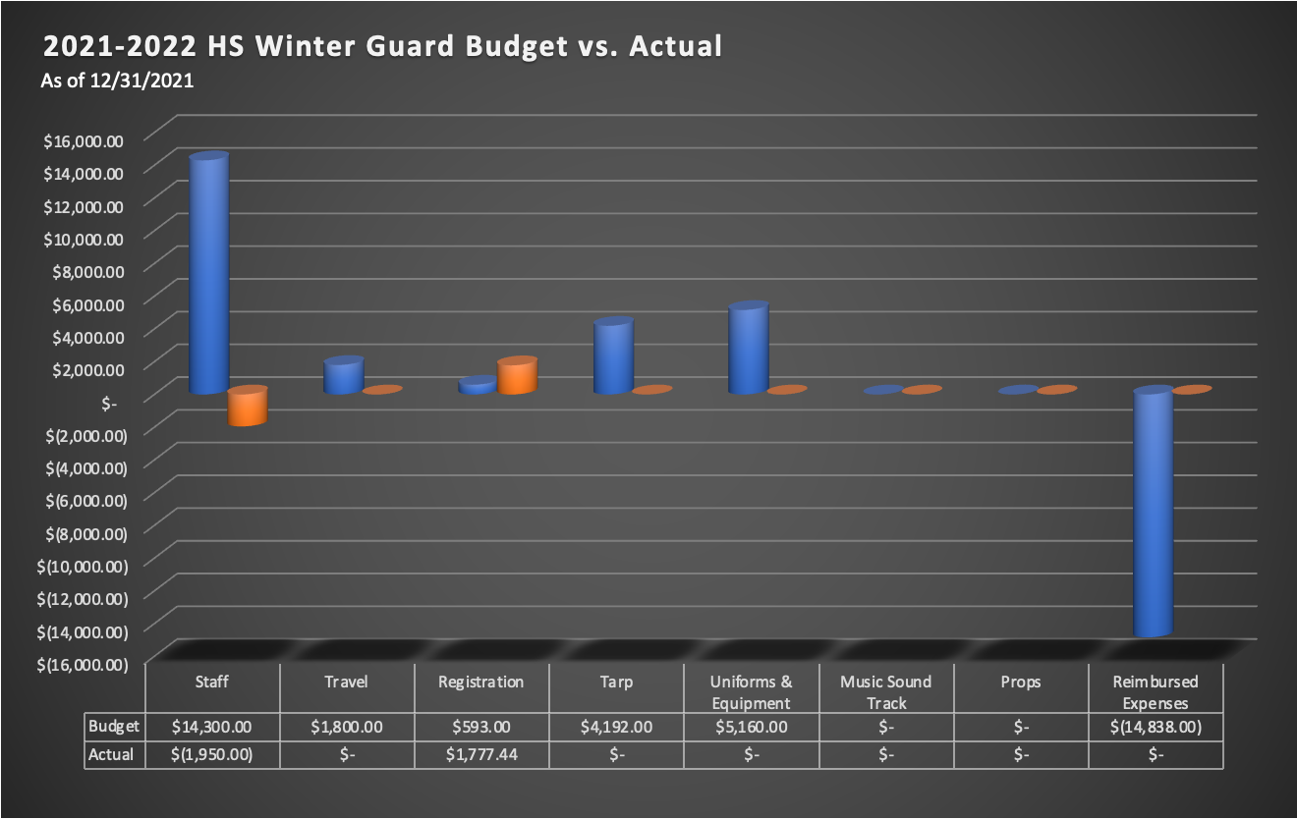
APPENDIX A
Treasurer Report
10Jan2022
Page 3/6

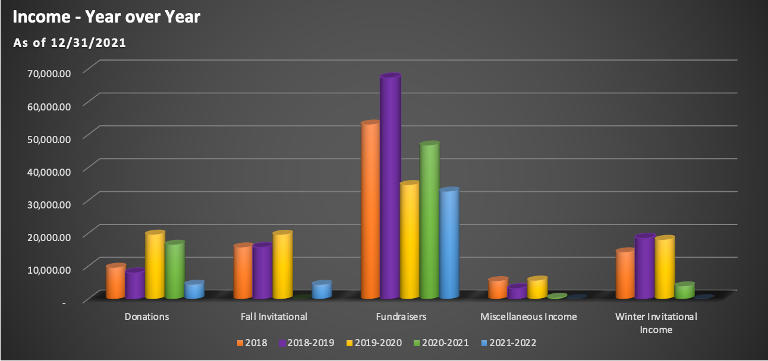

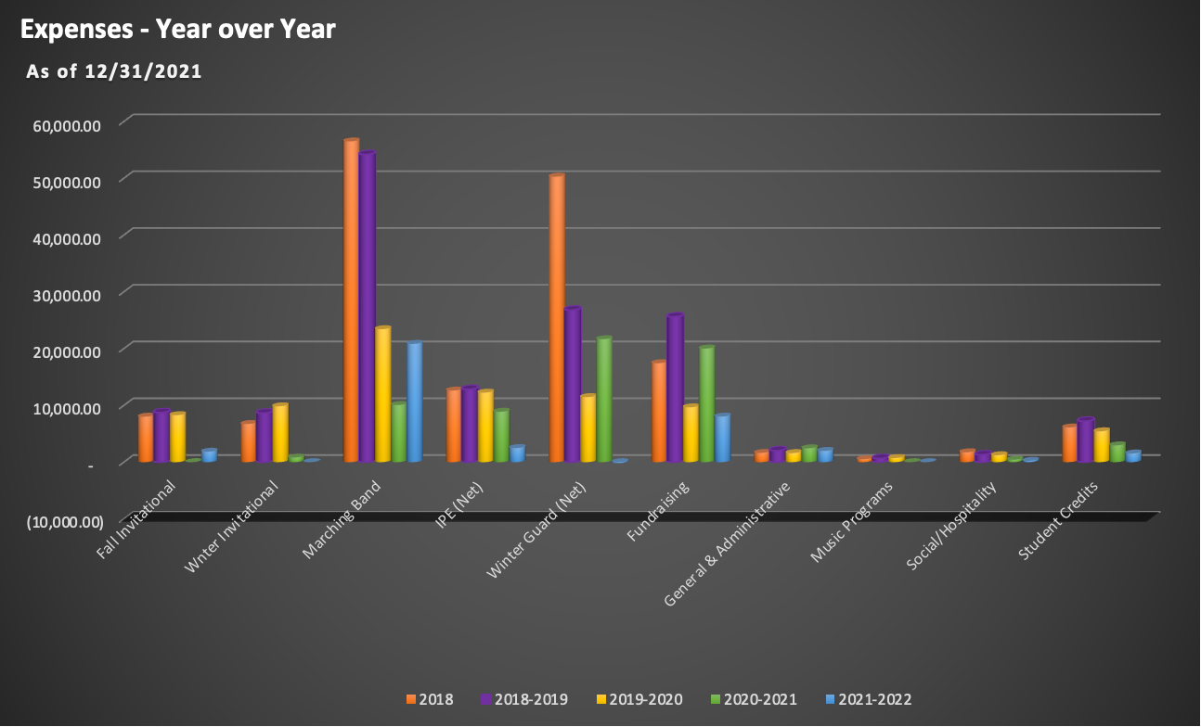

APPENDIX A
Treasurer Report
10Jan2022
Page 4/6

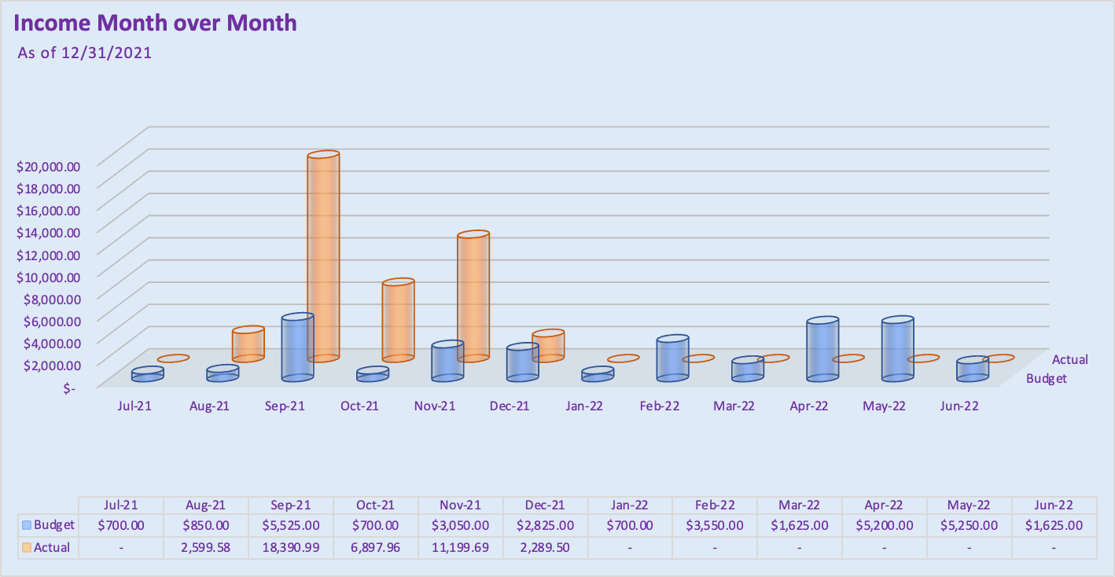

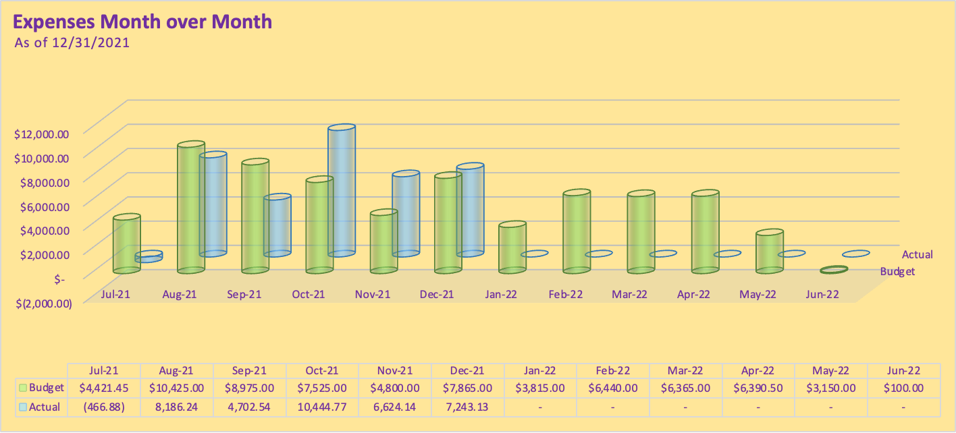

APPENDIX A
Treasurer Report
10Jan2022
Page 5/6

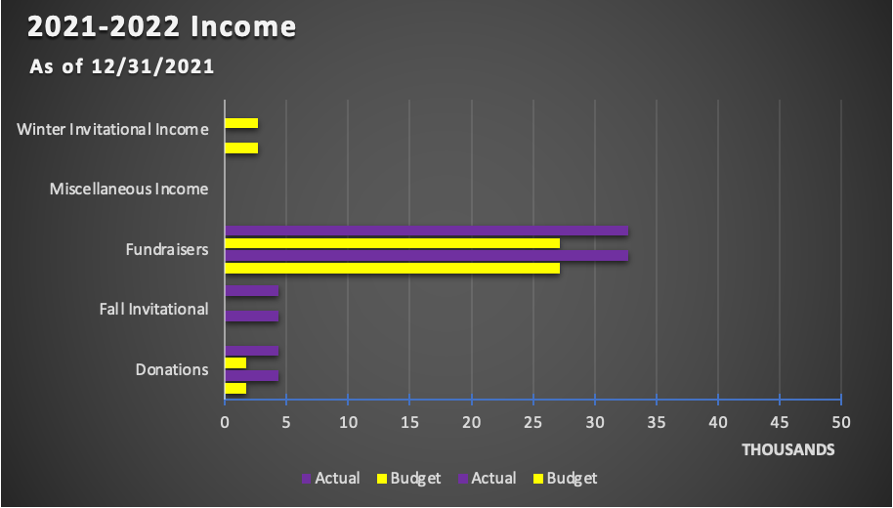

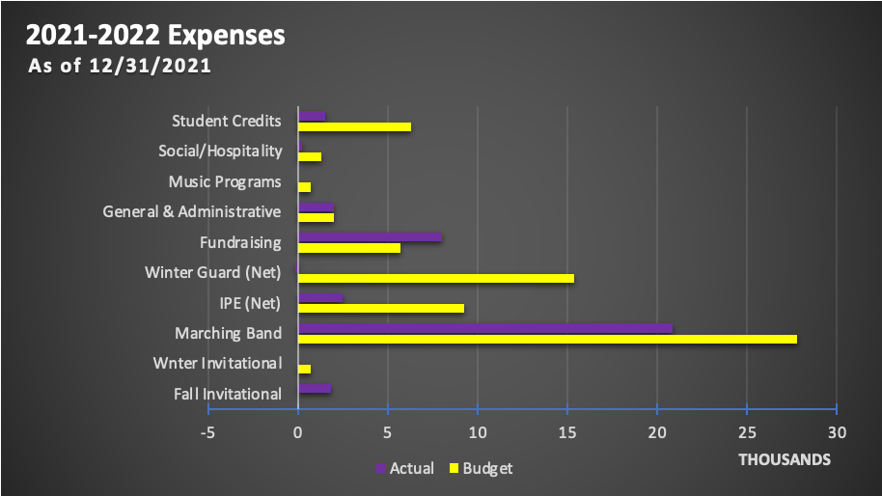

APPENDIX A
Treasurer Report
10Jan2022
Page 6/6

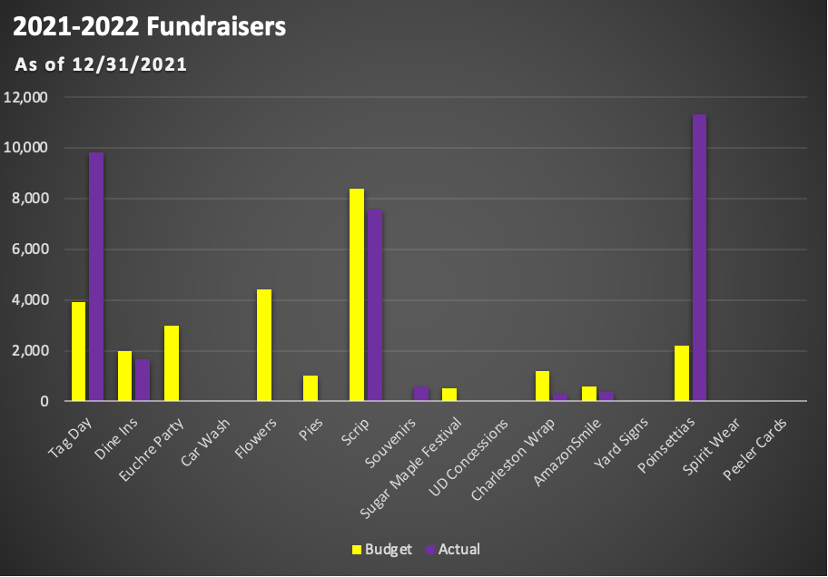

APPENDIX B
Director’s Report
10Jan2022

- Congratulations to all the concert bands on amazing December concert performances!
- Concerts coming up:
  - Saturday 1/22 - District Chamber Music Showcase! ***We have typically used this day as a way to reach out to families of middle school students and provide them with information about the boosters.! ***
  - Thursday 2/24 - Concert Band Festival
  - Saturday 3/5 - Music for All Concert Band Festival at Mason HS (times TBD)
- New York trip is being planned! $100 deposits as well as the first three $200 payments have already been paid.
- Jazz Band and Pep Band have started! Both groups are making great progress! Jazz band will have a guest clinician tomorrow, Mr. Wayne Markworth, who is going to talk to us about improvisation!
- Congratulations to Karin Peterson, Zane Pittman, and Matthew Jenkins for being selected to the Wright State Honor Band, taking place over President’s Day weekend!
- Next booster meeting will be preceded by our annual 8th grade parent night at 6pm. Students and parents are invited to attend to hear about music course offerings at the high school. Usually selected parents also speak, and 8th grade families are invited to the booster meeting at 7:15. Refreshments have often been provided…...?
- Tentative Disney Dates: 12/28/2022-1/2/2023 (look for a meeting in February, TBD)
- Marching band - Grand Nationals Bus Update
- Winter Programs
  - MEPA Bellbrook Invitational - Saturday, February 5
    - 39 groups are currently registered
    - Look for opportunities to volunteer/help with this event
    - Event mask policy: MEPA will be requiring masks for performers, staff, volunteers, and spectators at ALL events this season (announced at our director’s meeting Saturday). Performers are allowed to remove masks during warm up and/or performance at their discretion. I have forwarded this information to our district leadership so that they are aware.
  - IPE and Winterguard - seasons are underway and we’re looking forward to a great winter!

